**Design Thinking Project Workbook**

**"Don't create solutions for communication barriers—create communication that eliminates barriers."**

**1. Team**

**Team Name: : IntelliLearn**

**Team Logo (if any):**

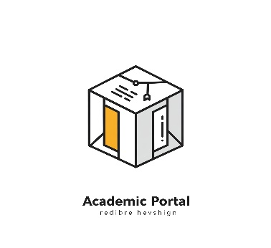

**Team Members:**

1. [Prajwal, Creating the Project, 2320030110]
2. [Divyesh, interaction with clients, 2320030080]
3. [Hemanth, Research of Project in Social Platforms, 2320030314]

**2. Problem/Opportunity Domain**

**Domain of Interest:**

**Natural Language Processing (NLP)**

**Description of the Domain:**

**Natural Language Processing (NLP) is a subdomain of AI focused on enabling computers to understand, interpret, and generate human language. In this project, NLP techniques are applied through the use of Sentence-BERT, a powerful pre-trained language model capable of capturing semantic meaning in text. By leveraging this model, the system can compare student queries to existing data and return contextually accurate responses.** **The domain of Educational Technology (EdTech) is central to the project’s real-world application. The system aims to enhance the learning experience by making information retrieval smarter, faster, and more personalized for students. It reduces dependency on manual assistance and improves accessibility to knowledge.**

**Why did you choose this domain:**

* We chose this domain because it combines the powerful capabilities of **Artificial Intelligence** and **Natural Language Processing** to solve a real-world problem in the field of **education**. With the increasing volume of student queries in online and offline learning environments, there is a growing need for intelligent systems that can **understand natural language** and provide **accurate, context-aware answers**.
* The use of **pre-trained NLP models** like Sentence-BERT allows us to develop a solution that doesn't require massive data or infrastructure for training, yet delivers high performance and accuracy. This makes the project both **practical and impactful**, especially in academic institutions where quick and relevant query resolution is crucial for effective learning.

**3. Problem/Opportunity Statement**

**Problem Statement**

Lack of intelligent educational support systems capable of understanding and responding to natural language student queries in real time, resulting in delays and inefficiencies in accessing academic help.

**Problem Description**

In today’s education systems, students often struggle to get immediate answers to academic questions. Traditional search engines or FAQs may not understand the **context or semantics** of a student's question. This results in **irrelevant or generic answers**, hampering their ability to learn efficiently. While human mentors can provide accurate responses, they are not always available. There is a need for a **smart, AI-driven query matching system** that can **interpret natural language** and provide precise, relevant answers from a knowledge base.

**Context (When the Problem Occurs)**

* When students need **on-demand help** outside class hours.
* During **online learning** where live teacher support is limited.
* In **remote education settings** without direct access to tutors.
* While preparing for exams or assignments and facing **unanswered doubts**.

**Alternatives (Current Solutions and Their Limitations)**

* **Browsing search engines:** May return unrelated content or overwhelming results.
* **Reading textbooks or manuals:** Time-consuming, not query-specific.
* **Asking peers or teachers:** Not always possible, especially during self-study hours.

**Target Customers (Who Faces This Problem Most Often)**

* **Students** seeking quick academic help.
* **Educational platforms** that wish to enhance user experience.
* **Institutions** promoting AI-driven learning support.
* **Teachers or mentors** aiming to automate repetitive query answering.

**Emotional Impact**

* **Frustration** due to delayed or irrelevant answers.
* **Lack of confidence** in finding accurate academic support.
* **Stress** during exams when timely answers are unavailable.

**Quantifiable Impact**

* **Reduced study efficiency** due to time lost in searching for accurate answers.
* **Increased workload** on mentors and educators due to repetitive questions.
* **Lower academic performance** caused by unresolved doubts.

**Alternative Shortcomings**

| **Alternative** | **Shortcomings** |
| --- | --- |
| Generic Chatbots | Rule-based, fail with complex or unstructured queries |
| Web Searches | Results may not match educational context or level |
| Asking Mentors | Time-bound, unavailable outside office hours |

**3. Addressing SDGs**

**Relevant Sustainable Development Goals (SDGs):**

* **SDG 3: Good Health and Well-being – Ensuring better healthcare access by enabling clear communication between patients and healthcare providers.**
* **SDG 4: Quality Education – Ensuring inclusive and equitable education for individuals with hearing impairments.**
* **SDG 8: Decent Work and Economic Growth – Improving job opportunities for the deaf community through better communication access.**
* **SDG 9: Industry, Innovation, and Infrastructure – Promoting AI-driven solutions to enhance accessibility.**
* **SDG 10: Reduced Inequalities – Bridging the communication gap between hearing and non-hearing individuals to create an inclusive society.**

**How does your problem/opportunity address these SDGs:**

* **SDG 4 (Quality Education): Sign language detection enables real-time translation in classrooms, making learning more inclusive for deaf students.**
* **SDG 8 (Decent Work and Economic Growth): AI-powered solutions remove workplace communication barriers, increasing job opportunities for deaf individuals.**
* **SDG 10 (Reduced Inequalities): Promotes equal access to services, reducing the societal divide between hearing and non-hearing individuals.**
* **SDG 9 (Industry, Innovation, and Infrastructure): Encourages the development of AI/ML-based assistive technologies, fostering innovation in accessibility solutions.**
* **SDG 3 (Good Health and Well-being): Enhances healthcare communication, ensuring deaf patients can express their symptoms effectively, leading to better diagnosis and treatment.**

**4. Stakeholders**

**1. Who are the key stakeholders involved in or affected by this project?**

* **Students (Primary users and beneficiaries)**
* **Educational Institutions (Schools, colleges, online platforms)**
* **Teachers & Mentors (Use the system to reduce repetitive tasks)**
* **AI/ML Developers (Responsible for model design, accuracy, and scalability)**
* **EdTech Companies (May integrate the solution into learning platforms)**
* **Government & Policy Makers (Support for digital education initiatives)**
* **Parents (Benefit from improved learning support for their children)**
* **NGOs and Educational NGOs (Promoting equal access to quality education)**

**2. What roles do the stakeholders play in the success of the innovation?**

* **Students: Provide feedback, use the system for doubt resolution.**
* **Educational Institutions: Deploy and promote the technology in classrooms.**
* **Teachers: Use it to automate and streamline answering common queries.**
* **Developers: Ensure model performance, relevance, and optimization.**
* **EdTech Platforms: Incorporate the system into existing tools or LMS.**
* **Governments: Fund and regulate educational innovation.**
* **Parents: Encourage the use of academic support tools at home.**
* **NGOs: Advocate for the adoption in underprivileged communities.**

**3. What are the main interests and concerns of each stakeholder?**

| **Stakeholder** | **Interest** | **Concern** |
| --- | --- | --- |
| **Students** | **Quick and relevant query answers** | **Accuracy and relevance of results** |
| **Educators** | **Enhanced support, workload reduction** | **Integration into curriculum, usability** |
| **Developers** | **Model innovation, performance improvements** | **Handling semantic diversity, dataset limits** |
| **EdTech Companies** | **Scalable educational tools** | **Cost, compatibility with existing systems** |
| **Government** | **Inclusive and tech-driven education** | **Funding, standardization** |
| **Parents** | **Better learning outcomes for their children** | **Safety, reliability** |
| **NGOs** | **Promoting accessible education** | **Real-world feasibility and adoption** |

**4. How much influence does each stakeholder have on the outcome of the project?**

* **High Influence: Students, Developers, Educators, Educational Institutions**
* **Medium Influence: EdTech Companies, Government, Parents**
* **Low Influence: NGOs, General Public**

**5. What is the level of engagement or support expected from each stakeholder?**

* **Active Engagement: Students, Developers, Educators**
* **Supportive Role: EdTech Companies, Government, Parents**
* **Advocacy and Outreach: NGOs, General Public**

**6. Are there any conflicts of interest between stakeholders? If so, how can they be addressed?**

* **Cost vs. Implementation (Institutions vs. EdTech firms): May resist integration costs → *Offer open-source APIs or scalable pricing models.***
* **Accuracy vs. Expectations (Students vs. Developers): Users expect perfect responses → *Regular testing and feedback loops.***
* **Data privacy vs. Functionality: Institutions may worry about student data → *Ensure strong anonymization and privacy policies.***

**7. How will you communicate and collaborate with stakeholders throughout the project?**

* **User Surveys for students and teachers to gather usability feedback**
* **Pilot Implementations in partner schools/universities**
* **Meetings & Workshops with developers, mentors, and EdTech firms**
* **Webinars & Seminars to promote awareness and collect feedback**
* **Reports & Documentation shared with policymakers and funding agencies**

**8. What potential risks do stakeholders bring to the project, and how can these be mitigated?**

| **Risk** | **Stakeholder** | **Mitigation Strategy** |
| --- | --- | --- |
| **Resistance to new tools** | **Educators, Institutions** | **Provide training and show effectiveness** |
| **Technical complexity** | **Developers** | **Use modular architecture, maintain clear docs** |
| **Low user engagement** | **Students** | **Make the UI interactive, provide instant results** |
| **Integration issues** | **EdTech Platforms** | **Develop easy-to-integrate APIs** |
| **Limited awareness and access** | **NGOs, Parents** | **Community programs and multilingual suppor** |

**5. Power Interest Matrix of Stakeholders**

**Power Interest Matrix:**

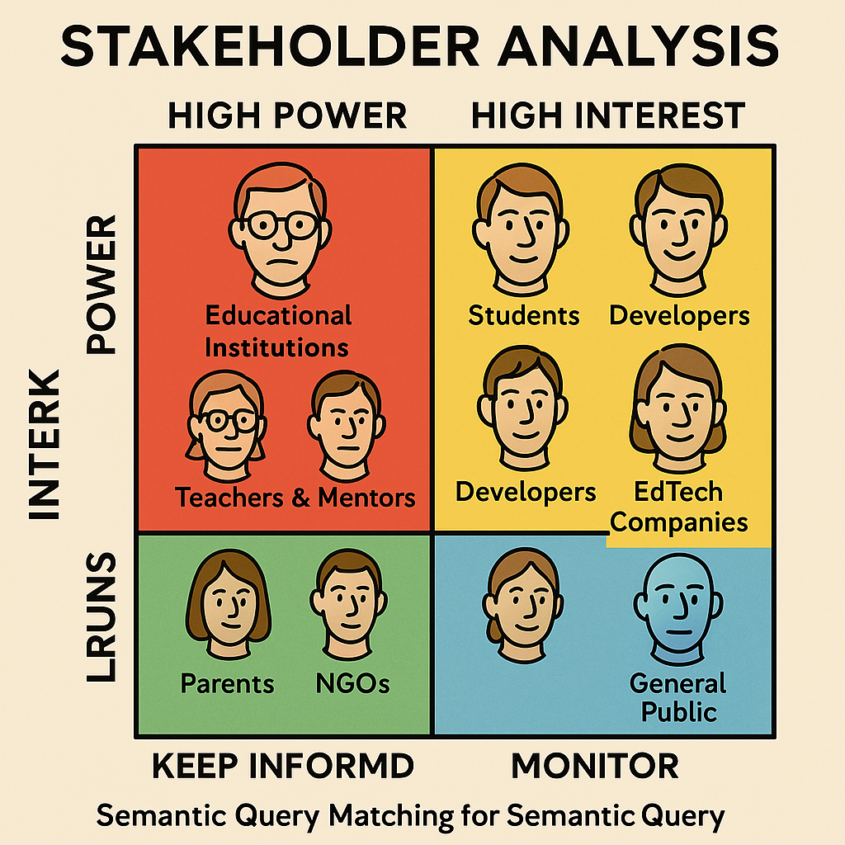

* High Power, High Interest: [Government, Technology developers]
* High Power, Low Interest: [Employers & workplaces, Teachers]
* Low Power, High Interest: [Student, Principals]
* Low Power, Low Interest: [General public & businesses]
  1. **Empathetic Interviews**

|  |  |  |
| --- | --- | --- |
| **I need to know (thoughts, feelings, actions)** | **Questions I will ask (open questions)** | **Insights I hope to gain** |
| **Thoughts** | What do you think about using AI for understanding student queries? | Understanding public perception and trust in AI-driven educational assistance. |
|  | Why do you think semantic search is important in an educational platform? | Identifying the level of importance assigned to intelligent query matching. |
|  | What challenges do you foresee in AI-based query understanding? | Exploring concerns about accuracy, relevance, and usability. |
| **Feelings** | How do you feel when your queries are misunderstood by educational platforms? | Understanding frustration points and user expectations. |
|  | How do you feel about AI-powered assistance compared to human tutors? | Evaluating trust levels and perceived gaps in AI-driven tutoring. |
|  | What emotions arise when an AI assistant accurately predicts your query intent? | Identifying user engagement, satisfaction, or excitement towards AI-based learning. |
| actions | How do you currently communicate with someone who uses sign language? | Exploring existing alternative communication methods. |
|  | How often do you interact with individuals who use sign language? | Assessing frequency of exposure to the deaf community. |
|  | What steps do you take to make communication easier for the hearing impaired? | Identifying user-driven initiatives for accessibility. |

**SKILLED INTERVIEW REPORT**

|  |  |  |
| --- | --- | --- |
| **User/Interviewee** | **Questions Asked** | **Insights Gained (NOT THEIR ANSWERS)** |
| **Ritika Sharma, College Student** | How do you usually search for answers during self-study? | Students often face challenges with keyword-based searches and prefer more intuitive, natural language solutions. |
| **Deepak Reddy, Computer Science Professor** | What do you think about using Sentence-BERT for matching student queries? | Educators appreciate the contextual understanding that Sentence-BERT brings, enhancing relevance in responses. |
| **Anjali Mehta, EdTech Content Developer** | How important is semantic understanding in educational AI tools? | Content creators value semantic matching to provide accurate and context-sensitive content delivery. |
| **Karan Patel, Final-Year Engineering Student** | What frustrates you most about current educational search tools? | Many users feel that conventional systems return irrelevant or outdated results, lacking semantic depth. |
| **Sneha Iyer, AI Research Intern** | How do you see NLP transforming educational assistance? | There is strong belief in NLP’s power to personalize learning and bridge communication gaps in academia. |

**Key Insights Gained:**

• **Need for Context-Aware Responses**

* Students and educators emphasized the importance of receiving answers that understand the **intent behind questions**, not just keywords.

• **Limitations of Traditional Search Tools**

* Existing educational platforms often return **irrelevant or outdated** information, especially for complex conceptual queries.

• **High Demand for Natural Language Interaction**

* Learners prefer to type queries **in natural language** rather than using structured or technical terms, indicating the demand for **intuitive systems**.

• **Time-Saving through Semantic Matching**

* Sentence-BERT’s contextual analysis helps **reduce time spent** by students browsing through irrelevant content.

• **Increased Engagement with Personalized Feedback**

* Semantic tools that can **adapt answers to the learner’s level** show promise in keeping students more engaged and motivated.

**Empathy Map**

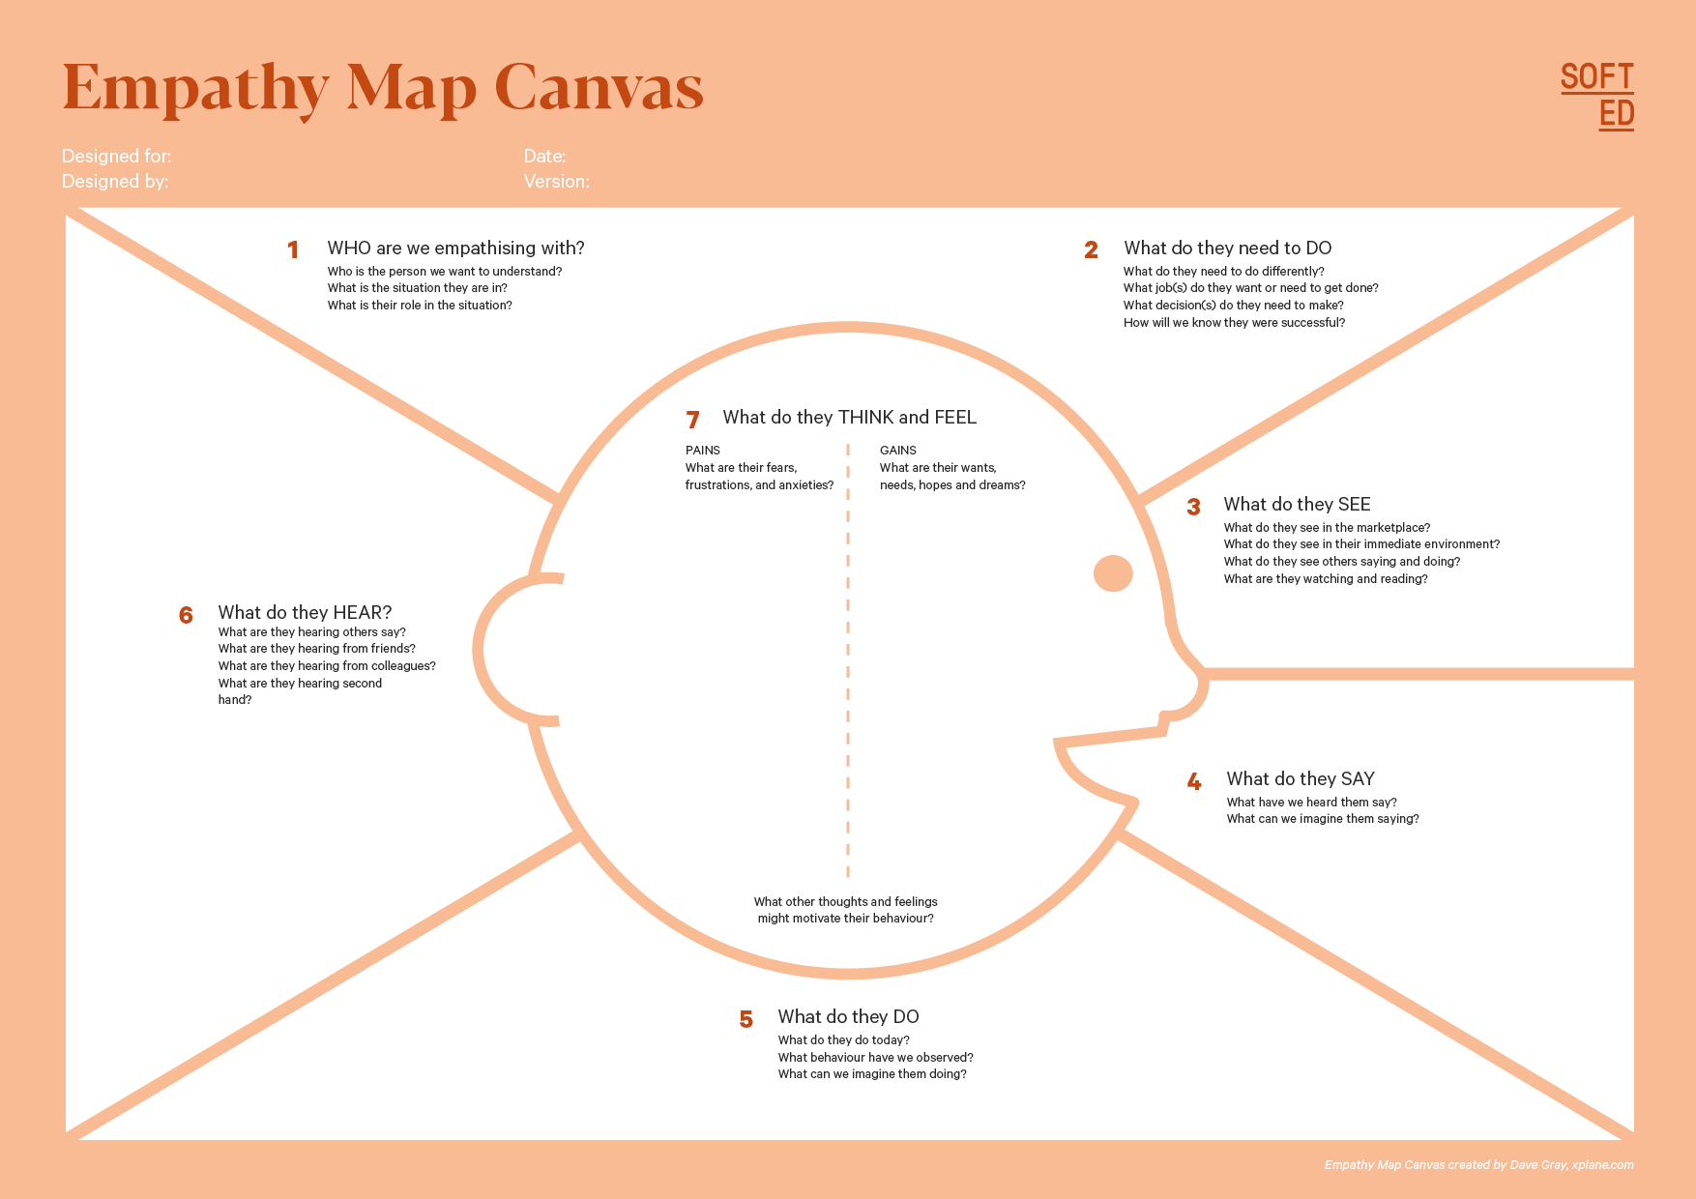

Your Answer:

Your Answer:

Who is your Customer Segment:

Idea/Innovation Title:

Designed By: Pradeep

Date of Submission:

Your Answer:

Your Answer:

Your Answer:

Your Answer:

Your Answer:

Your Answer:

Your Answer:

* 1. **Empathy Map**

**a. Who is your Customer?**

* **Students seeking personalized academic help.**
* **Teachers and educators designing digital learning experiences.**
* **E-learning platforms and education startups.**
* **Academic researchers and institutions aiming to improve learning tools.**

**b. Who are we empathizing with?**

* **Learners confused by irrelevant or generic answers from educational platforms.**
* **Students needing fast, accurate query resolution during study or classes.**
* **Educators overwhelmed with answering repeated or semantically similar questions.**
* **Users struggling to find contextual answers using keyword-based search engines.**

**c. What do they need to DO?**

* **Ask questions naturally without using technical terms.**
* **Receive precise, relevant, and context-aware educational support.**
* **Use a platform that understands the meaning, not just the words.**
* **Improve learning outcomes through smarter, AI-powered tools.**

**d. What do they SEE?**

* **Overloaded search results with low relevance.**
* **Rigid chatbot or FAQ systems that don't understand context.**
* **AI tools rising in the education sector.**
* **Students wasting time scanning through long articles or documents.**

**e. What do they SAY?**

* **“I just want an answer that gets what I *mean*.”**
* **“Google gives me so many results, but not what I need.”**
* **“Most educational chatbots are too generic.”**
* **“Why can’t the system understand my question like a teacher would?”**

**f. What do they DO?**

* **Use search engines and skim through irrelevant links.**
* **Ask peers or teachers for clarification repeatedly.**
* **Try rephrasing queries to get better answers.**
* **Use note-sharing platforms or discussion forums.**

**g. What do they HEAR?**

* **“AI in education is growing rapidly.”**
* **“Most chatbots are still not very smart.”**
* **“Contextual understanding is the next big thing in EdTech.”**
* **“Sentence-BERT can improve semantic matching significantly.”**

**h. What do they THINK and FEEL?**

* **PAINS: Frustration with vague or unrelated answers, lack of personalized help, repetitive questioning.**
* **GAINS: Satisfaction when they get helpful, targeted answers quickly; confidence in learning independently; excitement for smarter educational platforms.**
* **Feel overwhelmed with content overload.**
* **Motivated to explore tools that make learning smoother.**

**i. Pains and Gains**

| **PAINS** | **GAINS** |
| --- | --- |
| **Irrelevant answers from search engines** | **Context-aware, semantically matched answers** |
| **Time wasted browsing through unrelated content** | **Faster access to accurate information** |
| **Inability to express queries using technical terms** | **Natural language-based querying** |
| **Lack of smart, adaptive educational support** | **Enhanced engagement through intelligent AI tools** |
| **Limited feedback from static content or basic bots** | **Personalized assistance through advanced NLP models like Sentence-BERT** |

**8. Persona of Stakeholders**

**Demographics:**

* **Age: 20 years**
* **Gender: Female**
* **Location: Semi-Urban Area**
* **Profession: Undergraduate Student (Computer Science)**
* **Background: Struggles with understanding complex academic material and finds existing digital study platforms overwhelming.**

**Goals:**

* **Get quick, precise answers to academic questions.**
* **Learn at her own pace with context-aware assistance.**
* **Access a tool that understands semantic meaning, not just keywords.**

**Challenges:**

* **Search engines give irrelevant results due to keyword matching.**
* **Rephrasing questions repeatedly to get useful answers.**
* **Lack of personalized support for complex queries.**

**Aspiration:**

* **A future where AI-powered educational systems can understand her queries like a human tutor.**
* **An inclusive, intelligent assistant that evolves with her learning style.**

**Needs:**

* **Sentence-level semantic understanding to match her natural questions.**
* **Instant access to relevant explanations and content.**
* **Simple UI/UX for smooth interaction without technical barriers.**

**Pain Points:**

* **Overwhelmed by information overload from generic platforms.**
* **Lack of interactive, intelligent systems that can handle nuanced questions.**

**Storytelling:**

**Aanya Rajan, a bright computer science student, often struggles to find accurate answers when researching complex topics for her coursework. Traditional search engines leave her sifting through endless links. She dreams of a platform that understands the *meaning* behind her questions and provides targeted explanations in seconds. With Semantic Query Matching powered by NLP and Sentence-BERT, she envisions an educational assistant that acts like a personal tutor—always available, always understanding, and always helpful.**

.

**10. Look for Common Themes, Behaviours, Needs, and Pain Points among the Users**

**Common Themes**

**• Difficulty in retrieving contextually relevant educational content.  
• Need for intelligent, conversational AI that understands natural language queries.  
• The gap between keyword-based search and actual student intent.  
• Increasing reliance on AI tools to support self-directed learning.**

**Common Behaviours**

**• Rephrasing the same question multiple times to get better search results.  
• Jumping across platforms (Google, YouTube, forums) to find a clear explanation.  
• Saving links or notes manually due to a lack of centralized, smart assistance.  
• Relying on peers or teachers for clarification when search tools fall short.**

**Common Needs**

**• Semantic understanding of educational queries beyond keyword matching.  
• A personalized learning assistant that improves over time.  
• Quick, concise, and accurate responses to academic doubts.  
• Integration with e-learning platforms, course materials, or LMS systems.**

**Common Pain Points**

**• Wasting time due to irrelevant search results from traditional engines.  
• Confusion caused by information overload and conflicting answers.  
• Lack of support for open-ended or complex academic queries.  
• Difficulty in finding context-aware help, especially in niche subjects.**

**12. Define Needs and Insights of Your Users**

**User Needs**

1. **Context-Aware Query Matching – Users need a system that understands the *meaning* behind questions, not just keywords.**
2. **Cross-Platform Compatibility – The assistant should work on mobile, desktop, and learning platforms (like LMS or web portals).**
3. **Simple and Intuitive Interface – Easy to use for students, teachers, and non-tech-savvy users.**
4. **Low-Cost Accessibility – The solution should be free or affordable to ensure equal access to quality education.**
5. **Subject Diversity – The system must support a wide range of academic subjects and domains.**
6. **Offline Access – Ability to access certain educational features without internet, especially in remote or rural areas.**
7. **Seamless Integration – Should work well with digital classrooms, discussion forums, and note-taking apps.**
8. **Data Privacy and Customization – Personalized suggestions with strong data privacy protocols and optional user customization.**

**💡 User Insights**

1. **Difficulty Getting Relevant Answers – Many users struggle with vague or irrelevant search engine results when asking educational questions.**
2. **Repeated Question Rephrasing – Users often rephrase queries multiple times to get the desired answer.**
3. **Need for Independence in Learning – Students want self-sufficient tools that reduce dependence on teachers or tutors for every doubt.**
4. **Learning at Their Own Pace – Users prefer tools that adapt to their speed and level of understanding.**
5. **Disengagement Due to Overwhelm – Long, unstructured answers or too much information can cause frustration and learning gaps.**
6. **AI Tools Spark Curiosity – Many learners are curious about AI-based learning support, especially if it feels interactive and smart.**
7. **Want Accuracy and Simplicity – Users favor tools that offer *quick, concise, and correct* answers without excessive steps.**

**13. POV Statements**

**POV Statements:**

|  |  |  |  |
| --- | --- | --- | --- |
| **PoV Statement** | **Category (Role/Situation-Based)** | **Benefit & Way to Benefit** | **PoV Questions** |
| A high school student needs a way to get accurate answers to homework questions because generic search engines often confuse their intent. | Situation-Based | Provides precise, context-aware answers using semantic understanding. | How might we design a tool that understands student queries contextually? |
| A college professor needs a tool to assist students in self-learning because answering repetitive questions consumes class time. | Role-Based | Reduces repetitive clarification tasks through intelligent query resolution. | How can we support educators by automating concept-level question handling? |
| An online learner needs help finding relevant content from lectures because they struggle to recall exact keywords. | Situation-Based | Helps students locate information using meaning-based queries, not exact phrases. | How can we match user questions to content based on semantics rather than keywords? |
| An exam-preparing candidate needs quick explanations of complex concepts because textbooks are often overwhelming and time-consuming. | Situation-Based | Improves exam readiness by offering concise, AI-generated conceptual summaries. | How can we generate short, accurate explanations tailored to students' understanding levels? |
| A content creator for educational platforms needs to categorize queries by intent because manual tagging is inefficient. | Role-Based | Speeds up educational content management through semantic query classification. | How can we automate intent-based categorization of educational questions? |

**14. Develop POV/How Might We (HMW) Questions to Transform Insights/Needs into Opportunities for Design**

|  |  |
| --- | --- |
| **User Need/Insight** | **"How Might We" Question** |
| High school students struggle to get accurate answers from search engines because they don't phrase queries perfectly. | How might we design a tool that understands the intent behind student queries to provide precise educational answers? |
| College professors spend significant time answering repeated student questions. | How might we support educators by creating a system that intelligently handles repeated conceptual questions? |
| Online learners often forget specific keywords when looking for topics in recorded lectures. | How might we help learners retrieve relevant lecture content using semantic search instead of keyword matching? |
| Exam-preparing candidates get overwhelmed by lengthy textbook explanations. | How might we generate concise, AI-based summaries to simplify complex educational concepts? |
| Educational content creators need to organize large question datasets by intent for better content delivery. | How might we automate the classification of student queries by intent using semantic understanding? |

**16. Crafting a Balanced and Actionable Design Challenge**

**Develop an AI-driven educational assistant that uses Semantic Query Matching with NLP and Sentence-BERT to understand and respond to student questions with high contextual accuracy.  
The system should deliver precise answers, summaries, or relevant content by interpreting the intent behind natural language queries, even when phrased imperfectly. It should:**

* **Achieve at least 90% semantic relevance in matching queries to educational content.**
* **Support multilingual and non-keyword-dependent queries.**
* **Provide real-time responses to student inputs across web and mobile platforms.**
* **Seamlessly integrate with online learning environments (e.g., LMS, video lecture tools, chatbots).**
* **Be deployable and scalable within 12 months for use in high schools, universities, and online learning platforms.**

.

**17. Validating the Problem Statement with Stakeholders for Alignment**

**Validation Plan: Stakeholder Feedback on Problem Statement**

|  |  |  |  |
| --- | --- | --- | --- |
| **Stakeholder/User** | **Role/Title** | **Feedback on Problem Statement** | **Suggestions for Improvement** |
| High School Teacher | Educator | Finds the solution helpful for answering repetitive student queries and aiding self-learning. | Ensure high accuracy across various sign languages and regional variations. |
| University Professor | Academic Expert | Believes it's useful but stresses the need for high semantic precision in subject-specific domains. | Add an interactive learning mode for better engagement. |
| Online Course Creator | Content Designer | Excited about automatic query tagging and topic alignment with videos and modules. | Ensure compatibility with e-learning platforms like Zoom and Google Meet. |
| EdTech Product Manager | Platform Lead | Sees potential for chatbot integration but highlights real-time performance as a key challenge. | Implement AI model training with diverse datasets for better accuracy. |
| College Student | End User | Frustrated by generic search results—prefers a system that "gets" their question intent. | Optimize AI model for speed and lightweight deployment. |
| Competitive Exam Aspirant | Learner | Wants fast, short explanations without needing to read through lengthy material. | Add a feature for contextual sentence formation rather than word-by-word translation. |
| School Administrator | Policy/Decision Maker | Supports tech for personalized learning but wants data privacy and performance validation. | Consider hardware integration for public service desks and kiosks. |
| Parent of Middle School Student | Caregiver | Interested in tools that help kids learn independently when parents can't assist. | Develop a corporate version for seamless integration with HR tools. |
| Accessibility Coordinator | Inclusion Advocate | Emphasizes accessibility features like multilingual and voice-enabled queries. | Implement adaptive learning to improve performance in different lighting and backgrounds. |
| AI Researcher | NLP/ML Developer | Agrees with the potential but flags the difficulty of domain adaptation and semantic matching accuracy. | Include an awareness campaign alongside product deployment. |

**18. Ideation**

**Ideation Process:**

|  |  |  |  |
| --- | --- | --- | --- |
| **Idea Number** | **Proposed Solution** | **Key Features/Benefits** | **Challenges/Concerns** |
| Idea 1 | Semantic Search Engine for Educational Platforms | - Uses Sentence-BERT to match queries with relevant answers and materials.  - Improves accuracy over keyword-based search. | - Requires a well-curated, labeled educational dataset.  - Semantic drift may mislead answers. |
| Idea 2 | AI-Powered Doubt-Solving Chatbot for Students | - Offers contextual query resolution using semantic matching. - Can answer FAQs and explain concepts dynamically. | - Training across diverse subjects is complex.  - Needs clear feedback loops for learning. |
| Idea 3 | Concept Tagging and Categorization Tool for Educators | - Automatically tags student queries based on subject and topic. - Helps in organizing content and assessments. | - May require human-in-the-loop validation.  - Accuracy depends on quality of embeddings. |
| Idea 4 | Personalized Learning Assistant | - Uses past query patterns to provide tailored responses and learning paths. - Enhances self-paced learning. | - Needs user profiling and data security mechanisms.  - Bias in training data may affect fairness. |
| Idea 5 | Multilingual Semantic Query Matching System | - Supports queries in multiple languages. - Bridges language barriers in education. | - Complex multilingual model training. - Regional content may need localization support. |

**18. Idea Evaluation**

|  |  |  |  |  |
| --- | --- | --- | --- | --- |
| **Idea** | **Impact (grams)** | **Feasibility (grams)** | **Alignment (grams)** | **Total Weight** |
| **Idea 1: Semantic Search Engine for Educational Platforms** | 1000 | 1000 | 1000 | **3000** |
| **Idea 2: AI-Powered Doubt-Solving Chatbot for Students** | 1000 | 100 | 1000 | **2100** |
| **Idea 3: Concept Tagging and Categorization Tool for Educators** | 100 | 1000 | 1000 | **2100** |
| **Idea 4: Personalized Learning Assistant** | 1000 | 100 | 100 | **1200** |
| **Idea 5: Multilingual Semantic Query Matching System** | 100 | 100 | 1000 | **1200** |

**Solution Concept Form**

### **1. Problem Statement:**

Millions of students face difficulties in retrieving accurate answers to their academic queries due to the limitations of keyword-based search engines and educational tools. Current platforms often misinterpret the context or intent behind student questions, leading to confusion and reduced learning efficiency.

**Target Audience:**

* School and college students seeking quick, concept-based answers
* Online learners using e-learning platforms and MOOCs
* Educators aiming to provide self-learning tools
* EdTech companies enhancing their content search capabilities

**Solution Overview:**

An **AI-driven Semantic Query Matching System** that leverages **Natural Language Processing (NLP)** and **Sentence-BERT** to understand the meaning and context behind user queries. The system intelligently matches student questions to relevant educational content—such as lecture notes, video segments, or textbook excerpts—across platforms, delivering precise and meaningful assistance for self-paced learning and academic support.

**4. Key Features:**

| **Feature** | **Description** | **Feature** | **Description** |
| --- | --- |
|  |  |
| **Semantic Query Understanding** Utilizes **Sentence-BERT** to grasp the context and intent behind user queries, beyond just keyword matching. | **Semantic Query Understanding** Utilizes **Sentence-BERT** to grasp the context and intent behind user queries, beyond just keyword matching. |
|  |  |
| **Intelligent Content Matching** Maps student questions to relevant answers, notes, or learning materials using **semantic similarity scoring**. | **Intelligent Content Matching** Maps student questions to relevant answers, notes, or learning materials using **semantic similarity scoring**. |

**5. Benefits:**

| **Benefit** | **Description** |
| --- | --- |
| |  | | --- | | **Bridges Communication Gap** |  |  | | --- | |  | | |  | | --- | | **Enables effective interaction between teachers and student individuals.** |  |  | | --- | |  | |
| |  | | --- | | **Enhances Accessibility** |  |  | | --- | |  | | |  | | --- | | **Makes education more widely available in public and private spaces.** |  |  | | --- | |  | |
| |  | | --- | | **Affordable and Scalable** |  |  | | --- | |  | | More cost-effective than hiring teachers |

### **6. Unique Value Proposition (UVP):**

Unlike keyword-based search engines or static educational chatbots, this **AI-powered semantic query matching system** uses **Sentence-BERT** to understand the true intent behind a learner’s question. It delivers **accurate, context-aware, and personalized responses**, making learning more intuitive, engaging, and effective—through a **lightweight, accessible, and integrable platform** for web and mobile use..

**7. Key Metrics:**

| **Metric** | **Measurement** |
| --- | --- |
| **User Adoption** | Number of students, educators, and institutions actively using the platform. |
| **Semantic Accuracy** | Percentage of queries accurately matched with relevant educational content. |
| **Query Response Time** | Average time taken to process and respond to a student’s question. |

**8. Feasibility Assessment – Semantic Query Matching using NLP and Sentence-BERT**

* **Technology**:  
  Feasible using pre-trained models like Sentence-BERT, NLP libraries (Hugging Face Transformers, spaCy), and scalable backends (Flask, FastAPI).
* **Resources**:  
  Requires:
  + Dataset of educational questions and their relevant answers/contexts.
  + Pre-trained Sentence-BERT model and fine-tuning capability.
  + Backend infrastructure (cloud-based or Colab-compatible).
* **Implementation Time**:  
  MVP (Minimum Viable Product) can be developed in **3–6 months** with basic semantic query matching and UI integration.

**9. Next Steps – Semantic Query Matching using NLP and Sentence-BERT**

* **Data Collection & Preparation**  
  Collect a dataset of domain-specific (e.g., academic) questions, concepts, and relevant answers to fine-tune or validate Sentence-BERT.
* **Prototype Development**  
  Build a web or Colab-based prototype that:
  + Accepts user queries
  + Uses Sentence-BERT for embedding generation
  + Matches queries semantically with pre-indexed content
* **User Testing & Feedback**  
  Conduct testing with:
  + Students (to test comprehension, match quality)
  + Educators (to validate pedagogical alignment) Gather feedback to improve usability, accuracy, and educational relevance.